Results:

Option A:
BreathMetrics and NC parameters were extracted from the averaged 10-minute pre- and post-donation rest periods, followed by paired t-tests comparing the two conditions. In the donor group, 13 of the 28 parameters survived FDR correction, whereas none survived in the control group. However, this discrepancy may be partially attributable to the substantially smaller control sample.

A between-group comparison of the pre–post deltas, as well as a mixed-model ANOVA, showed no statistically significant group effects.

Option B:
As we expected to see change toward sympathetic tone, we choose 3 relevant parameters:

Minute ventilation was increased after donation, before: 2242.4 ± 473.9, after: 2426.901 ± 475.141 (n=100), paired ttest, t(99) = 2.99, p=0.003. In addition, both peak inspiratory flow and peak expiratory flow increased following donation (PIF: before: 6.982 ± 1.695 ,after: 8.120 ± 1.743 (normalized units). PEF: before: -5.243 ± 1.414 (n=99); after: -6.020 ± 1.580 (n=99) ,paired tests: t(97) = -5.51, p=2.98e-07,t(98)=4.87, p=4.332e-06 respectively.
We did not see this trend toward sympathetic tone in the control group: No significant change in any of these parameters (all p>0.49).
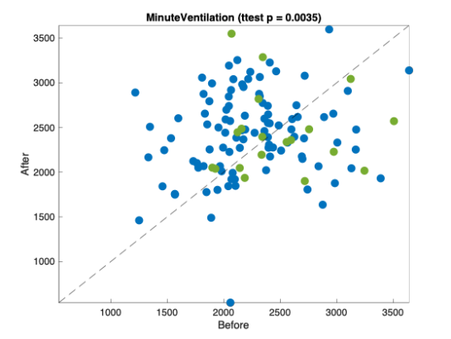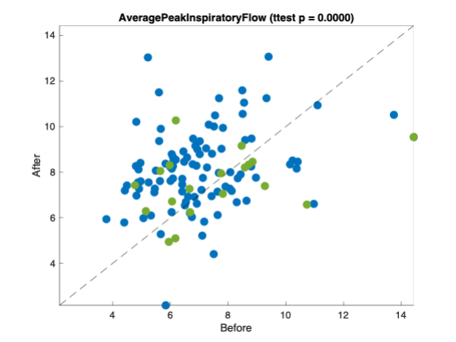
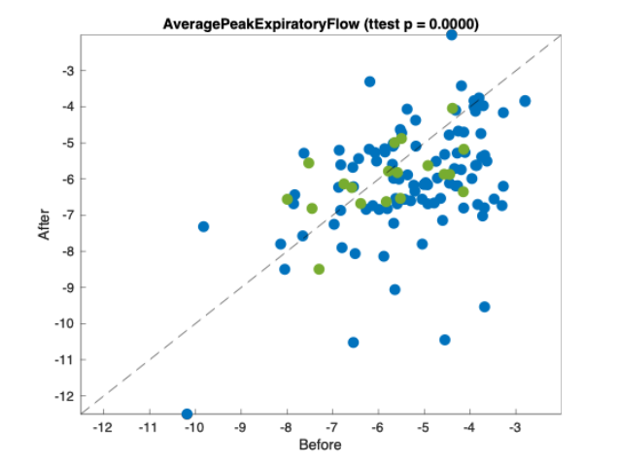

Although these strong effects in the within participants comparisons. Linear mixed model for these three parameters show only trend toward significant interaction between the groups.
minute ventilation (interaction: p=0.17), PIF (p=0.03), and PEF (p=0.066). The same trend can be shown if we compare the deltas (After-Before) between groups. MV: p=0.09), PIF (p=0.02), and PEF (p=0.07).

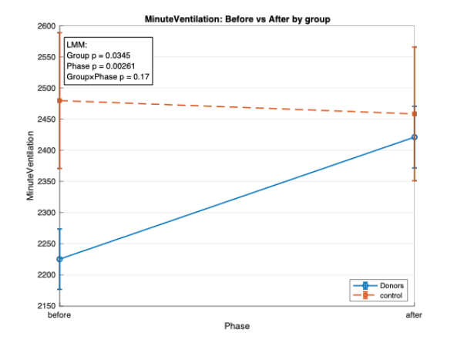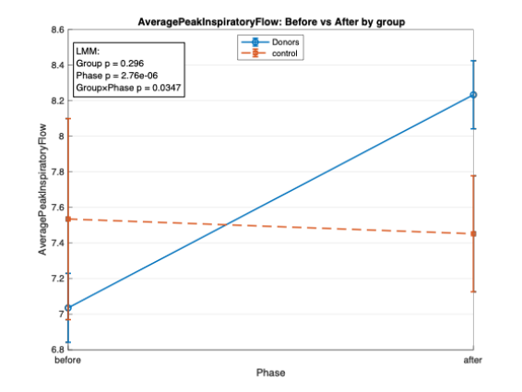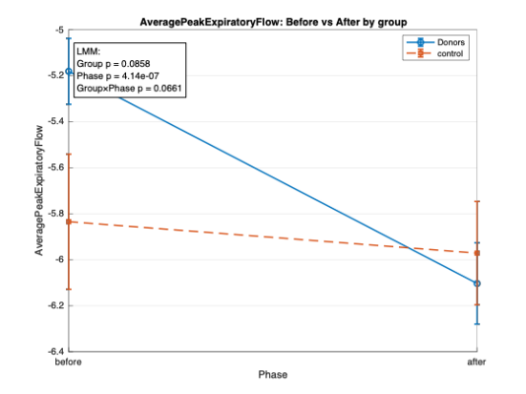

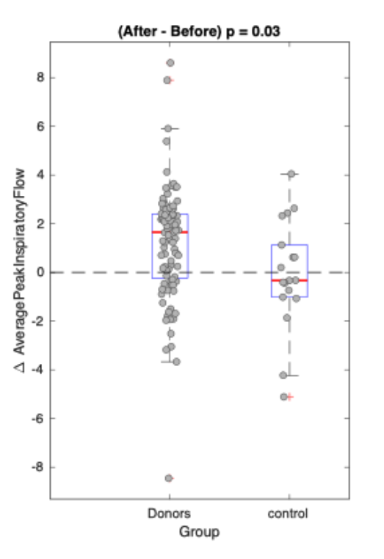
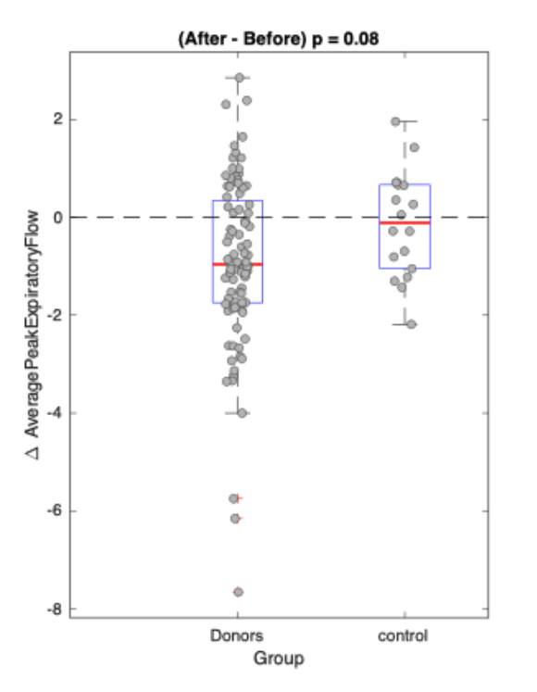

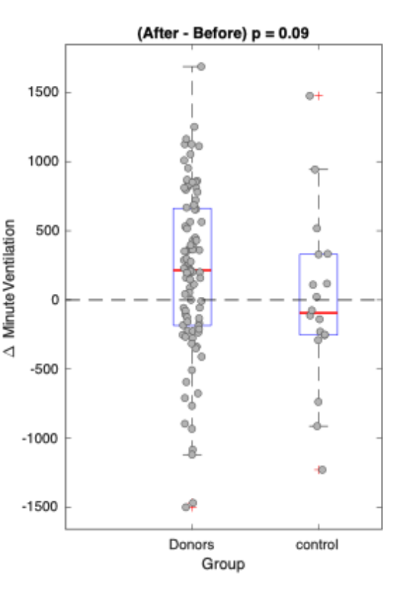

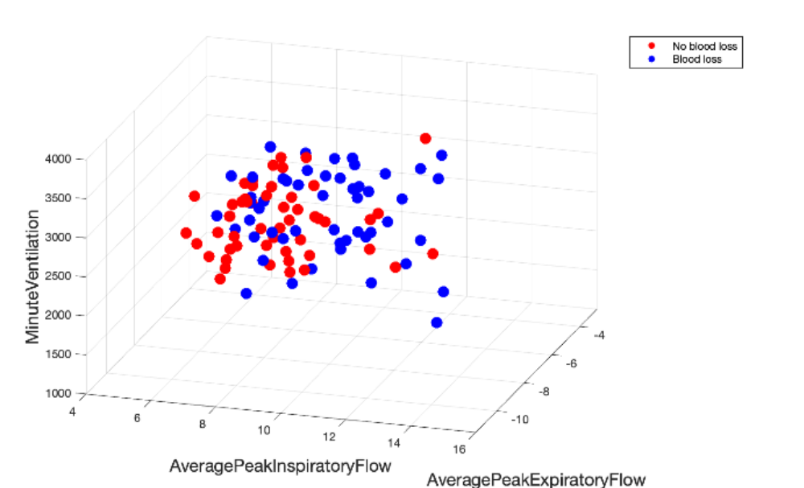

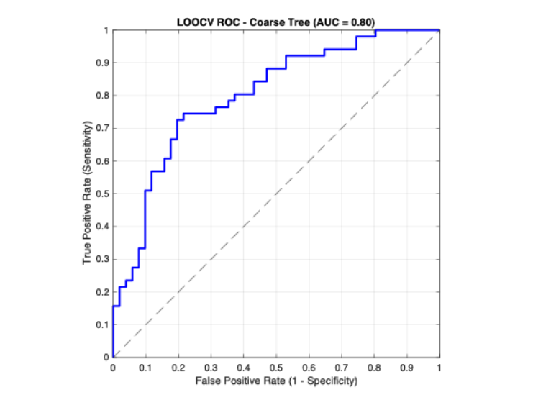

Classification between subjects gives (74.5 % accuracy, and ROC of 0.8),(SVM, train on half test on the other half). leave on out gives 72% and ROC of 0.77 .

Correlation to donation and weight?

2. מדמם לא מדמם- אני שוב בבעיית posture
לא ידעתי איזה מקטע לקחת..

During the Donation

תחילת סוף דימום+
בתוך נבדק לאורך תרומת הדם לראות סלופ

Paired ttest between the first 2 minutes of donation (30 sec after needle in) and last 2 minutes
Reavealed 12/28 parameters which survived FDR. 2 of them survived also in the control analysis.

Again, as this is might biased by sample size differences we chose to compute a slope per participant (linear fit to 10 bins interval each participant), and compared it between the two groups. 2 parameters survived FDR correction, PIF (t(100) = 3.458, p = 0.0008, d = -0.919, corrected p=0.014), and average inhale volume (t(100) = 3.341, p = 0.00118, d = -0.910,corrected p=0.014).

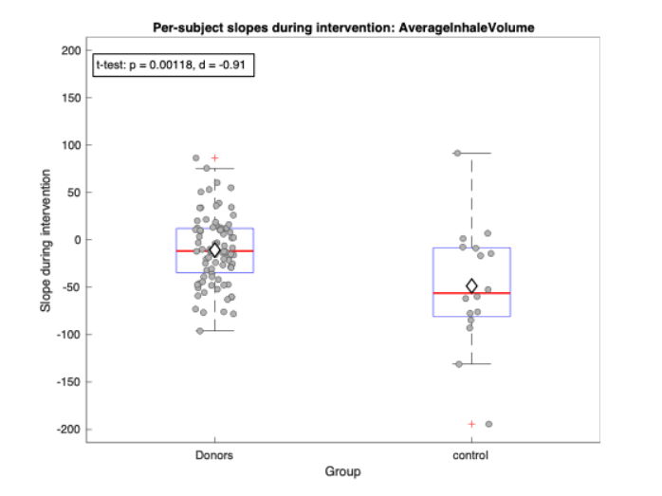
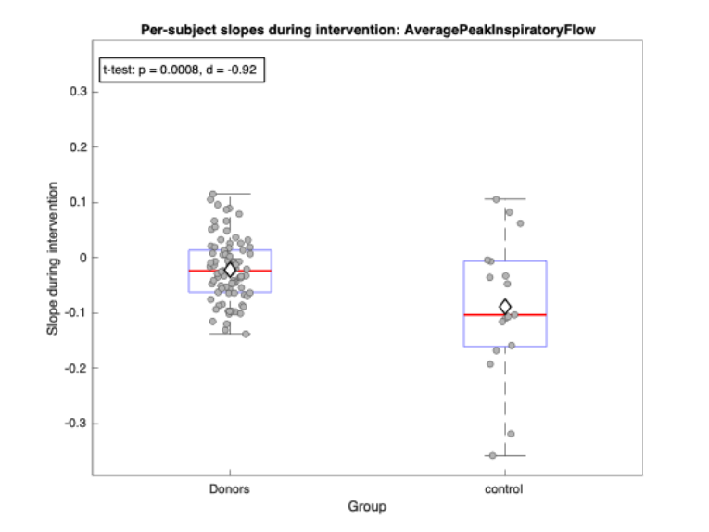

Next, we again calculated a mixed linear model (time-10 intervals, vs. group). None of the comparison survived multiple comparisons but there were few trends:

DC_exhale_pause- interaction p=0.0512

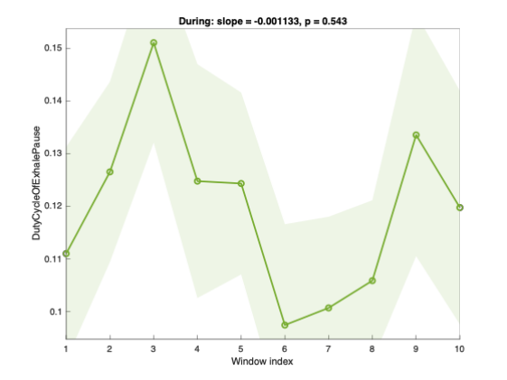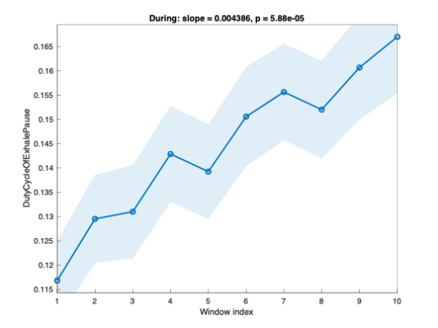

PercentOfBrethsWithExhalePause= 0.0722

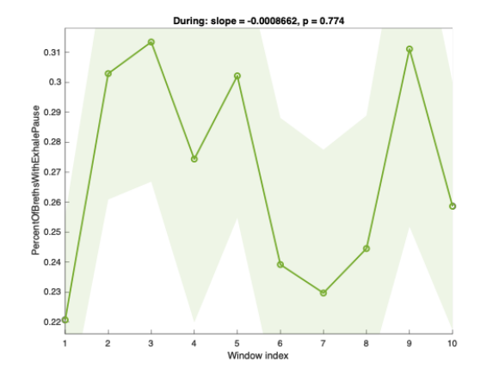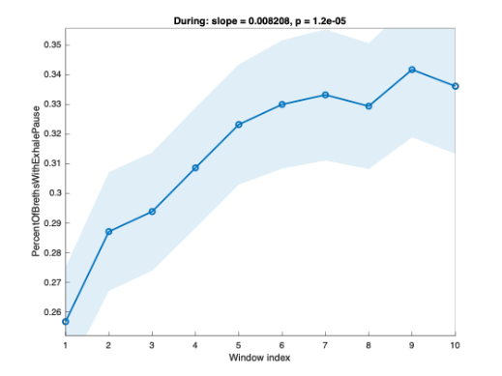
BreathingRate= 0.0379
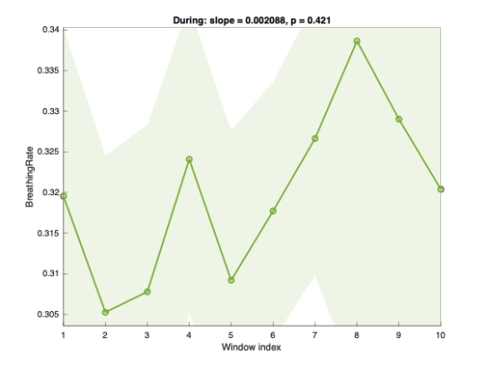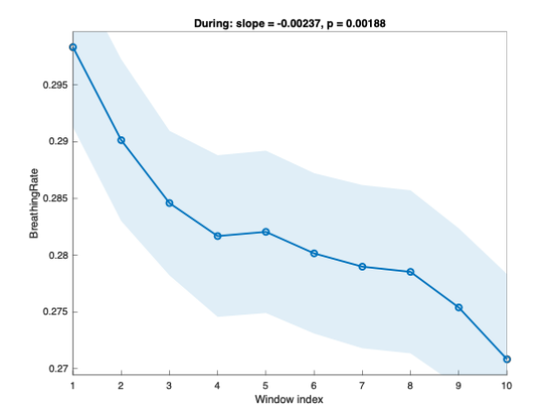

AverageExhaleVolume= 0.0376

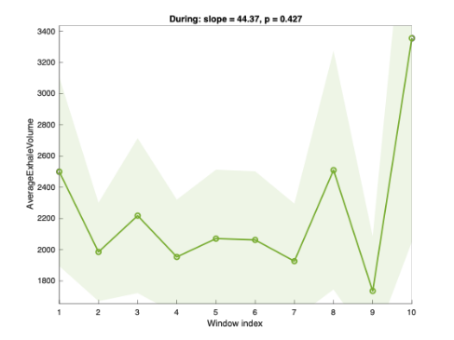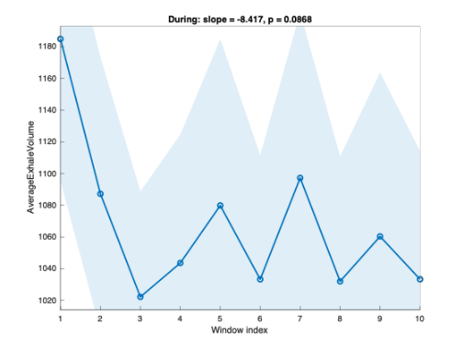
AverageExhalePauseDuration= 0.132

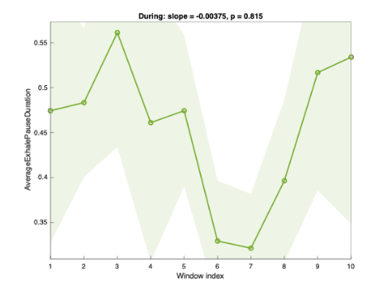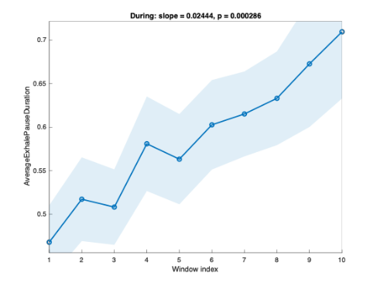

Participants
A total of 107 participants completed the IRB procedure. Of these, six participants ultimately did not donate blood, and one physiological recording was corrupted. The final donor sample therefore included 100 participants (weight: 71.02 ± 10.76 kg; height: 171.49 ± 19.71 cm; age: 20.04 ± 1.6 years). Mean baseline heart rate and oxygen saturation were 74.33 ± 10.81 bpm and 98.38 ± 1.23%, respectively.
Four donors chose to stop their donation mid-procedure; donation volume excluding mid-termination cases was 479.9 ± 27.7 ml.
The control group included 20 participants, one of whom stopped mid-session.
Procedure:
10 minutes rest before donation ->Donation -> 10 minutes rest after donation

